
Kwangwoon University Application Form
(Exchange Student)
Please write in English in all capital letters.
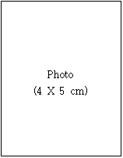
1. Name in Full:
(Surname) (Given name)
2. Gender: Male Female
3. Date of Birth: (MM) (DD) (YY)
4. Nationality:
5. Home Address : _______

6. Phone No.:
7. Mobile No.:
8. E-mail:
9. Name of Home University: Major: Grade:
10. Applying Major & Duration at Kwangwoon University
Major: / Duration: 1 year: 1 semester:
11. Language Proficiency
Language | Excellent | Good | Fair | Poor
Korean
English
12. Dormitory Application: Yes:____ No:____ / Period: 1 year:____ 1 semester:____
13. Emergency Contact Information
Name in Full:
Relationship to Applicant:
Address:
Phone No.: Mobile No.:

I certify that all information provided on this form is correct and true; I hereby agree to abide by all the rules and regulations of Kwangwoon University.

Date of Application: (MM) (DD) (YY)
Applicant's Name: Signature:

